# Exploring the BiConsumer Functional Interface in Java 8

## Introduction

In this tutorial, we will **code and explore** the **BiConsumer Functional Interface** in Java 8. Each functional interface has **an extension**, and \*\***BiConsumer** is an extension of the **Consumer Functional Interface**.**

## Methods in BiConsumer Interface

1. Open **IntelliJ IDEA** and press **Shift** twice to open the **Search Everywhere** window.

2. Search for **BiConsumer Interface** and examine its methods.

3. 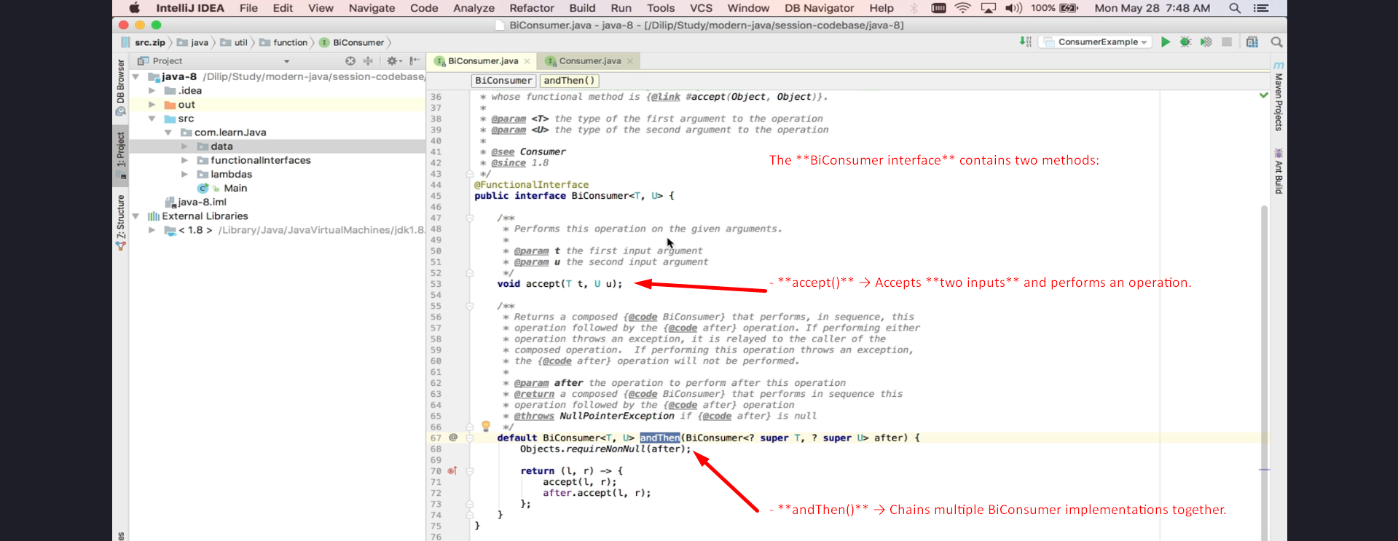

## Difference Between Consumer and BiConsumer

- **Consumer** → Accepts **one input** and performs an operation.

- **BiConsumer** → Accepts **two inputs** and performs an operation.

- If a scenario requires **processing two inputs together**, BiConsumer is preferred.

## Implementing BiConsumer Functional Interface

1. Create a new class **BiConsumerExample**.

2. Make the class executable by adding the **public static void main()** method.

3. Implement **BiConsumer<String, String>** to accept two String values and print them.

### **Code Implementation:**

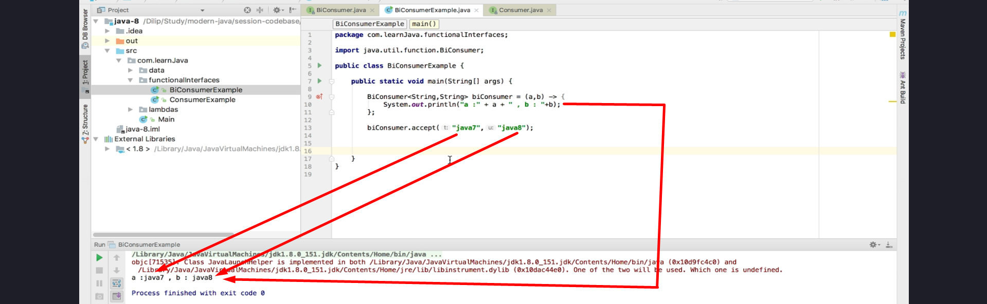

## Implementing Mathematical Operations Using BiConsumer

1. Modify **BiConsumer** to perform mathematical operations like multiplication and division.

2. Use `andThen()` method to **chain operations together**.

### **Code Implementation:**

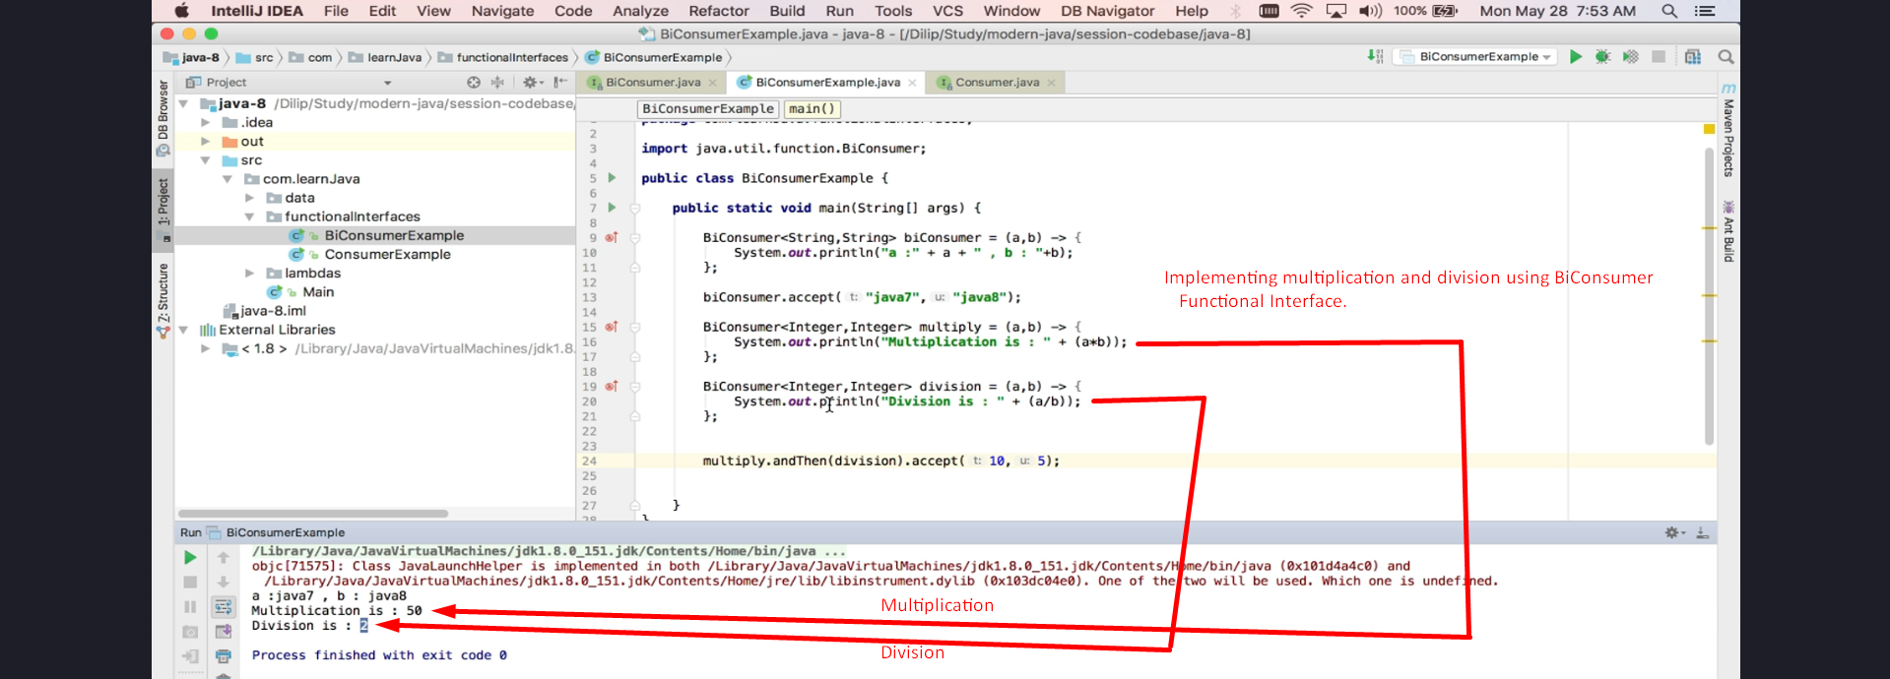

## Real-World Use Case: Student Name and Activities

1. Modify the previous **ConsumerExample** implementation to use **BiConsumer**.

2. Instead of handling **name** and **activities** separately, use BiConsumer to process both together.

3. Use `forEach()` to iterate over student data and print details.

### **Code Implementation:**

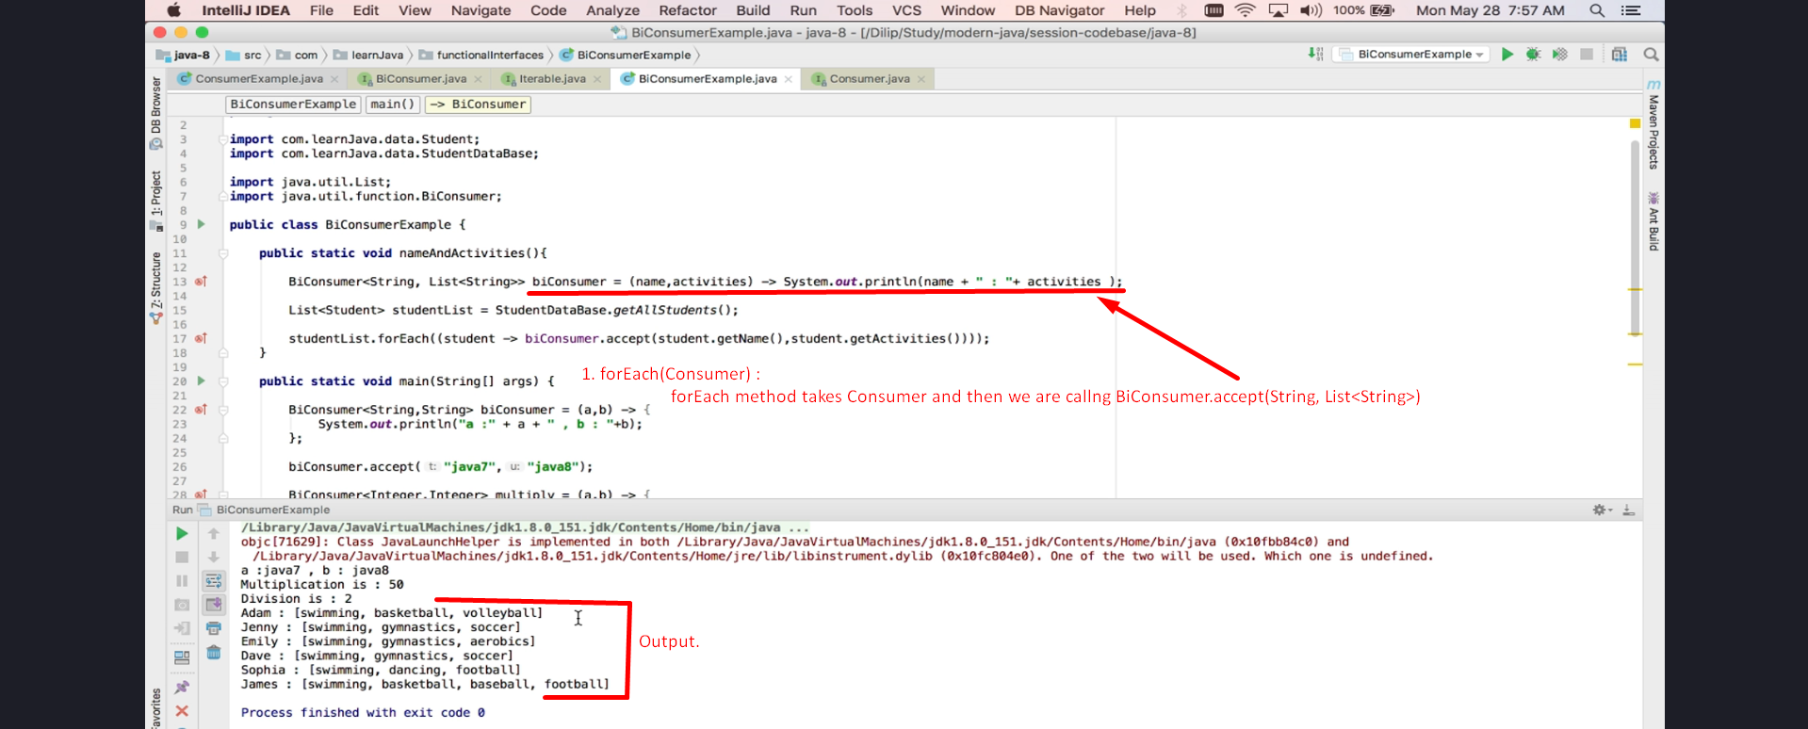

## Comparison Between Consumer and BiConsumer

1. **Use Consumer** when only **one input** is needed (e.g., printing student names).

2. **Use BiConsumer** when **two inputs** are required (e.g., name + activities).

3. There is **no performance difference** between Consumer and BiConsumer; use them as per your use case.

## Chaining Multiple BiConsumer Functional Interfaces

1. The \*\***BiConsumer.andThen()**\*\* method allows chaining multiple BiConsumers.

2. You can **add N number of BiConsumers** using `**andThen()**`.

### **Code Implementation:**

BiConsumer<Integer, Integer> add = (a, b) -> System.out.println("Addition: " + (a + b));  
BiConsumer<Integer, Integer> subtract = (a, b) -> System.out.println("Subtraction: " + (a - b));  
  
multiply.**andThen**(division).**andThen**(add).**andThen**(subtract).accept(10, 5); 🡸 **Chaining** **Multiple BiConsumer**.

## Conclusion

- **BiConsumer** **is an extension of the** **Consumer Functional Interface** that accepts **two inputs**.

- It is useful for **processing two related inputs** together (e.g., name and activities, mathematical operations).

- The **andThen()** method **allows chaining multiple BiConsumers** for sequential operations.

- Understanding **when to use Consumer vs. BiConsumer** helps in writing cleaner, reusable, and efficient Java 8 code.

### **End of Tutorial**

Thank you for watching!